Product Decomposition
Design Organization: Example for The Mechanical Design Process |  | Date: Aug 14 2007
Product Decomposed:: Irwin Quick Grip – pre 2007
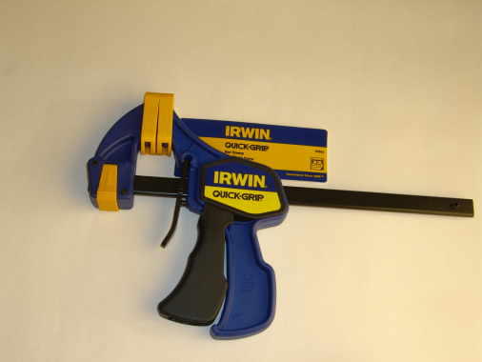
Description This is the Quick-Grip Product that has been on the market for many years

How it works: Squeeze the pistol grip repeatedly to move the jaws closer together and increase the clamping force. Squeeze the release trigger to release the clamping force. The foot (the part on the left in the picture that holds the face that is clamped against) is reversible so the clamping force can be made to push apart rather than squeeze together.
Parts:
Part # | Part Name | # Req’d | Material | Mfg Process | Image
1 | Main body | 1 | PPO or PVC | Injection molded
2 | Trigger | 1 | PVC | Injection molded
3 | Bar | 1 | Steel | Cold rolled
4 | Face plate, left | 1 | polyethylene | Injection molded
5 | Face Plate, right (burned as part of ID process) | 1 | polyethylene | Injection molded
6 | Tail stock | 1 | PVC | Injection molded
7 | Lock | 1 |  | Injection molded
8 | Pad | 2 |  | Injection molded
9 | Roll pin | 1 | Steel | Rolled Sheet
10 | Knurled pin | 1 | Steel | Cold rolled
11 | Release trigger spring | 2 | Steel | Wound wire
12 | Release trigger | 1 | Steel | Stamped sheet
13 | Power spring | 1 | Steel | Wound wire
14 | Jam plates | 2 | Steel | Stamped Sheet
15 | Label | 1 | PVF | Cut sheet
16 | Split pins | 2 | Steel | Rolled sheet

Disassembly:
Step # | Procedure | Part #s removed | Image
1 | Take off Left Face Plate | 4
2 | Take off right Face Plate and label | 5, 15
3 | Remove Tail Stock assembly | 6,7,8,9,10
4 | Remove one of the split pins | 16
5 | Remove Main Body assembly | 1,2,8,11,12,13,14
6 | Press out Roll Pin from Tail Stock assembly | 9
7 | Press out Knurled Pin from Tail Stock assembly | 10
8 | Pry off Lock from Tail Stock assembly | 7
9 | Pry off Pad from Tail Stock assembly | 8
10 | Remove Release Trigger from Main Body Assembly | 12
11 | Remove Trigger Springs from Main Body Assembly | 11
12 | Remove Jam Plates and Power Spring from Main Body Assembly | 13,14
13 | Remove Trigger from Main Body Assembly | 2
14 | Pry off Pad from Main Body assembly | 8

Links and drawing files:
Team member: | Prepared by:David Ullman
Team member: | Checked by:
Team member: | Approved by:
Team member:

The Mechanical Design Process Copyright 2018, David G. Ullman

